Use cases for gSKI core system design
Jacob Crossman, Soar Technology

Single Action Uses

User wants to setup/shutdown system.

1. Initialize System

Basic initialization process consists of creating an instance of the Kernel object. This is done through a global factory method.

Kernel* pKernel = CreateKernelInstance(…)

Parameters we may want during creation include:

* Multi-threading support policy
* Operator (O) support mode

2. Shutdown System

Shutdown in a single threaded environment should involve calling a single method to destroy the primary kernel. Three options are available

pKernel->Release() // reference counting (preferred)
pKernel->Destroy() // destroy itself
DestroyKernelInstance(pKernel) // mirror the factory method

To support multi-threaded execution, the kernel should not be destroyed by the client directly (e.g. by calling delete),

Multi-threaded shutdown will be more complex. It consists of asking the kernel to shutdown, and then waiting for execution to stop. From the user perspective it can be the same as single threaded shutdown if we block the call to the shutdown function until shutdown is finished. Perhaps the best choice is to set up a multi-threaded policy object to manage these details (like blocking on shutdown).

3. Create an Agent

Creating an agent is done through the agent manager. It is a simple process.

Agent* pAgent = pKernel->GetAgentManager()->CreateAgent(Name,
ProductionSet,
bLearningOn);

Here production set can be either a file or an in-memory buffer. It may be nice to add flag parameters such as “run-immediately” or “run-immediately-separate-thread.”

4. Destroy an Agent

Destroying an agent is similar to shutting down the system. In a single threaded environment, shutting down is a single call. I suggest reference counting:

pAgent->Release()

This should free up all memory associated with the agent and make callbacks into the system to ensure attached objects know the agent is going away. If we actually use reference counting we may want a callback when release is called (even if the agent is not going away).

In a multi-threaded system, release may have to block until the agent decision processing reaches a point where shutdown is possible.

5. Add a Right-hand-side (RHS) functions

Adding a RHS function is also simple.

// Create rhs function
RetType my_rhs_func(…) { }

// Register it with the kernel
pKernel->AddRhsFunction(Name, my_rhs_func);

The name is used by soar productions to access it. The method will ensure that the same RHS function is not added more than once.

Multi-threading is an issue. Multi-threading may require blocking until the end of a decision phase. Another option is disallow adding RHS functions while the system was running.

6. Remove RHS functions

Removing a RHS function is a single call:

pKernel->RemoveRhsFunction(my_rhs_func);

Has the same multi-threading issues as adding RHS functions.

User wants to execute agents

1. Run All Agents

Internally, agent execution will need to be handled by the agent manager. It would be nice to be able to run agents in their own threads, or to at least simulate. (Simulating it may be possible).

From the user perspective, you can choose to batch run agents, or to run one at a time. You can choose to run in the current thread (effectively blocking) or to run in a new thread (created by gSKI). Finally, you can choose to execute for varying lengths of time.

Multi-threading should be handled through the multi-thread policy. Policy modes should be set before kernel creation. Possible multi-threading modes are:

a. Single Thread
b. Multi-thread safe (calls are safe from multiple threads)
c. Multi-threaded, controlled by gSKI (gSKI creates and manages threads)

Multi-threading support may be included in the form of agent-thread pairings (pairing one agent per thread, several agents in a thread, etc). The user would create these pairings, and run agents though an “execution manager” object for that set of agent-thread pairings. This may be possible eventually, but right now, we would only support all agents in one thread.

For running all agents the user executes a single agent manager method:

pKernel->GetAgentManager()->Run(Length);

Here length can be:

a. UntilStop: Run until all agents stop
b. UntilOutput: Run until all agents put something on the output link
c. N decision cycles: Run all agents N (N > 0) decision cycles
d. N elaboration cycles: Run all agents N (N > 0) decision cycles
e. One phase (proposal or application): Run all agents a single phase

This will run all “active” agents for the specified period of time.

2. Run Single Agent (Same options as run all agents

The user cannot run one agent at a time directly. However the user can set an agent’s mode to active or inactive. Active agents will make decisions while running, while inactive agents are skipped over in the agent processing.

To activate an agent:

pAgent->SetActive(true);

To deactivate an agent:

pAgent->SetActive(false);

As usual, multi-threading may require the function to take effect at the end of a decision phase.

3. Stop agent execution

You can stop all agent execution for a particular thread in a single step. There are different modes for stopping just as there are for running. They are:

a. EndCallback: Stop after completing current/next callback.
b. EndElaboration: Stop after the completion of current elaboration phase.
c. EndPhase: Stop after current proposal, selection, or application phase.
d. EndDecision: Stop after current decision phase.

One of these modes may be passed to the Stop method as follows:

pKernel->GetAgentManager()->Stop(Mode);

Typical reasons for stopping agents include pausing agents in a separate thread and breaking on some condition during debugging.

Note: All agents running in the given thread are stopped simultaneously.

User wants to configure agents

1. Load Productions

Loading productions can be done at agent creation time (as shown above) or at any time while the agent exists. You may load productions from one of the following:

a. From a file
b. From a memory

If the data is in ascii form, they can both be handled by the same, overloaded method:

pAgent->LoadProductions([file | mem_buffer])

This method may fail if the file doesn’t exist or cannot be accessed.

It may be desirable to have a separate function to load a single production. The need for such a function would mainly be if we can specify adding a production in an already parsed form (as some production structure). gSKI would support this through the following call:

pAgent->LoadProduction(Production);

Multi-threading will require waiting until a decision cycle is over before this function executes.

2. Load Rete Net

Rete nets can be loaded from file only (though it would be nice to support loading from memory).

pAgent->LoadRete(file);

As usual, there may be an error when operating on a file.
We may not be able to do this after an agent starts running? Multi-threading issues are similar to Load Productions.

3. Save a Rete Net

Rete nets can be saved to file only (though it would be nice to support saving to a memory block).

pAgent->SaveRete(file);

As usual, there may be an error when operating on a file.
Don’t know if we can save rete after executing decisions. Multi-threading issues are similar to Load Productions.

4. Excise Production(s)

Productions can be exised in a single step by calling a method of the agent as follows:

pAgent->ExciseProduction(Name)

The production will be excised as soon as it is safe to do so (end of decision cycle).

5. Retrieve an agent

Users can gain access to any agent at any time by requesting it by name from the agent manager.

Agent* pAgent = pKernel->GetAgentManager()->GetAgent(NameOfAgent);

Names must be unique.

6. Turn learning on/off

The user can turn learning on and off at any time with a single method call.

pAgent->SetLearning(true | false);

Multi-threading support requires waiting until next decision phase before it takes effect.

7. Set o-support mode

O-support mode may not be settable at run-time. If it is, it will be an agent level parameter:

pAgent->SetOSupportMode(Mode)

Multi-threading support requires waiting until next decision phase before it takes effect.

8. View productions

Production viewing is a multi-step process. The production manager is responsible for organizing and searching production sets. The production manager can be obtained through the agent interface.

ProductionManager* pPM = pAgent->GetProductionManager();

You can then query the production manager for productions or iterate over all productions.

9. Collect performance stats

There will be a performance monitor object in the system to collect and expose performance statistics. The kernel will provide access to this object, which can be queried for particular information, and configured to collect certain information.

pKernel->GetPeformanceMonitor();

User wants to know agent status/execution

1. Get current phase

The agent provides information as to the current phase.

PHASE_TYPE p = pAgent->GetCurrentPhase()

2. Get performance information

As mentioned above, performance information is available through the Performance Monitor. It should provide information on the following:

a. Get amount of memory used
b. Get time spent executing
c. Get number of decision cycles executed
d. Get number of elaboration cycles executed

It may also collect information in the form of a database so that the stats for each decision cycle are stored separately.

3. Get version

Version information is available through the kernel object.

float version = pKernel->GetVersion();

4. Get o-support mode

O-support mode can be found through the agent object.

O_SUPPORT_MODE m = pAgent->GetOSupportMode();

User wants to query/manipulate agent memory

Agent memory access and management will be handled by a set of I/O management objects. Here we look at how a user can gain access to the working memory control objects.

1. Get the input link

The user can obtain a pointer to the input link through the agent object. The input link can be searched and modified at any time. The user may register callbacks with the input link to be notified of agent “pull” (agent’s requesting information from the simulation).

InputWmeManager* pILink = pAgent->GetInputLink();

Manipulations to the input link should be safe in a multi-threaded environment.

2. Get the output link

The user can obtain a pointer to the output link through the agent object. The output link can be searched at any time (though it may not be modifiable). The user may register callbacks with the input link to be notified of agent “pull” (agent’s requesting information from the simulation).

OutputWmeManager* pOLink = pAgent->GetOutputLink();

Manipulations to the output link should be safe in a multi-threaded environment.

3. Get working memory

Working memory can be obtained the same way as the input and output links.

MainWmeManager* pMem = pAgent->GetMainWorkingMemory();

Short, multi-step paths

This section includes some use cases that touch multiple regions of the system.

1. Startup system, create a single agent with a known production file, run the agent until it stops, cleanup.

2. Startup system, create multiple agents and run them one-decision at a time inside of a single-threaded simulation loop.

3. Starup system, create multiple agents and run them in a separate thread until they complete, then shutdown system.

4. Create initial link.
a. Using simulation push
b. Using agent pull

5. Build-up infrastructure for handling output

a. Using simulation pull
b. Using agent push

6. Configure system to break on a production match.
a. For all production firings
b. For single named production

7. Find store the names of all productions that:

a. match a given lhs pattern
b. match a given lhs pattern AND match a given rhs pattern

8. Find and store the names of the productions that created a wme that has “operator.name” as its attribute value.

Global Issues

1. Interfaces.

We have already agreed to make all externally accessed objects accessible only through abstract interfaces. This minimizes coupling and compile/build dependencies.

2. Threading.

It would be nice to have a uniform way of handling multi-threading.

Proposal: Configure a thread-policy object that can create locks, threads, etc. Have all objects used this policy object to manage multi-threaded access.

Note: The boost threading library may be a good basis for the threading support.

3. Object Lifetime Management

For consistency, it would be nice to handle object creation and lifetime similarly. Reference counting is a nice solution considering that our objects may be accessed across processes and certainly across threads. It would be worth the effort to implement a consistent reference counting scheme in the system, together with wrappers to handle the counting (and ensure correct deletion).

4. Iteration.

When iterating on data accessed through an abstract interface, it is necessary to create special iterators that are independent of any internal data structures. We already have iteration code in our mini-library. With some small modifications it should solve the iteration problem nicely.

5. Debug mode

There are two issues related to debug mode. First, there may be things that we don’t want to expose for safety purposes during release mode (e.g. allowing direct changes to working memory). Second, there may be things we don’t want to support during release mode for efficiency reasons.

The usual answer for the second issue is compile time switches. But that is not sufficient here. For example, we may want to run in release mode, but when something goes wrong, connect a debugger to the system and switch to debug mode. If we can dynamically change from debug to release and vice versa, we will have a more flexible and robust system.

The first issue may not be important enough to deal with. The user can always force the system into the mode he/she desires and it may be more complexity than we need. However, we should give this a bit more thought before throwing it away entirely.

Thoughts for Production Manager

There are enough tasks related to production management, that a separate production manager is warranted. The production manager would act as a database management system for productions. Its primary interface would be a set of querying functions. You should be able to query based on:

a. Production name pattern
b. Production creation technique (hard coded, chunk, jusfication)
c. Production RHS conditions (including chained conditions)
d. Production RHS conditions (including chained conditions and RHS functions)
e. Production matches (allowing specification of particular wmes being matched)

It should (if possible) support some form of regular expression search for conditions and names.

Results should be encapsulated in some form of production set (collection of productions). Productions themselves would be wrapped in an object containing:

a. LHS Conditions (set)
b. RHS Conditions and actions (set)
c. Support (O/I/Unknown)
d. Matches (consisting of a set of wme’s paired with conditions)
e. Name
f. Descriptive Text

Thoughts for Querying Agents

It is useful to query both production sets and wmes for information. These querying take the form of pattern matching. Often these queries contain both wme and production information or are related to their combination (like matches). It may be desirable to have a separate object to manage agent querying (like a DBMS would). We could then create a query language for agent knowledge and allow general queries on what an agent knows (both long and short term).

Object Infrastructure Design

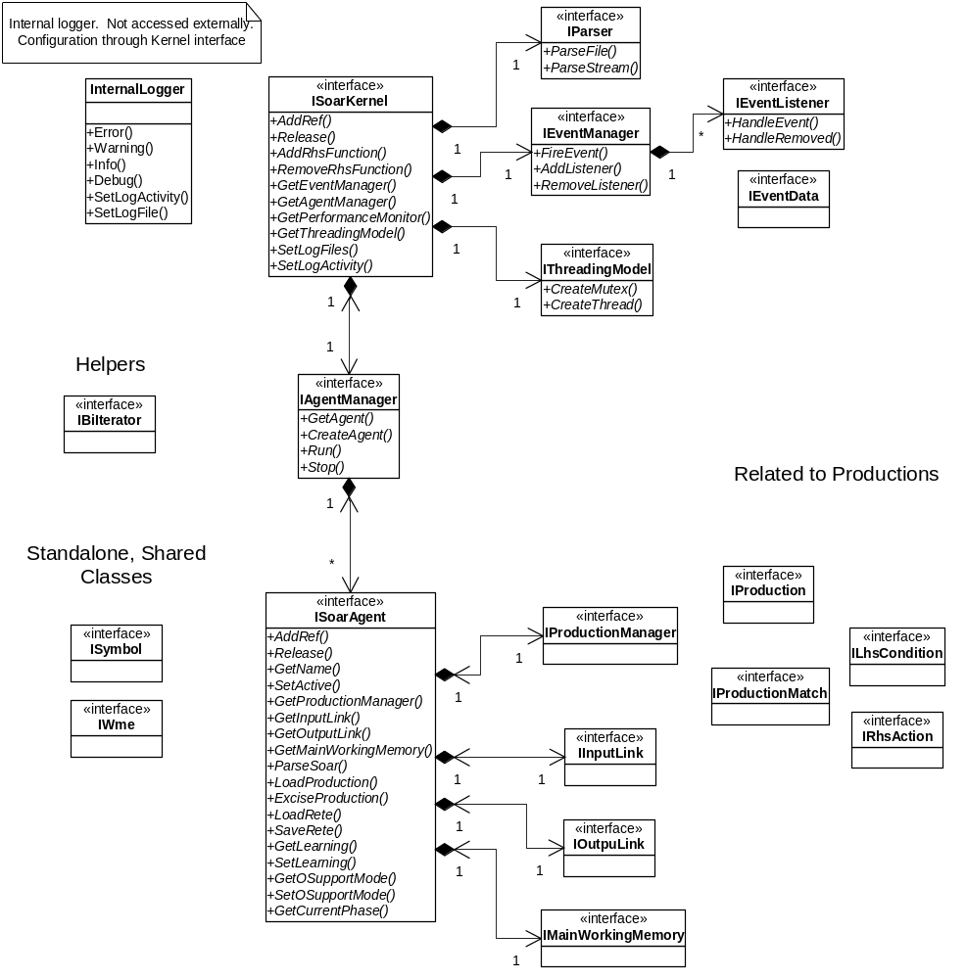

ISoarKernel:

This interface will serve as the entry point into the soar system. It wraps the soar kernel and provides access to the agent manager as well as other top-level objects such as the event manager and RHS functions.

An important part of the kernel is the Threading model object. This object will allow the thread-safety of the system to be configured as desired. The threading model will provide for the creation of read/write locks, threads, mutexes and any other thread management objects necessary to keep the system thread safe. If the system is configured to be single threaded, these objects will have no overhead (either storage or execution time).

IAgentManager:

The agent manager is responsible for creating and managing agents. The most complex part of this task is running and stopping the agents. Currently, the agent manager has the responsibility to run agents because each agent cannot be run individually. However, if this becomes possible later, we may want to break off the responsibility for running agents and give it to a separate agent/thread pairing object.

DIAGRAMS HERE

ISoarAgent:

The soar agent object is the central interface for accessing agent information. It provides accessor functionality for the production manager, input link, output link and main working memory. It also provides methods for loading and saving productions as well as manipulating agent settings (e.g. learning).

Soar agents cannot be run directly, they must be run through the agent manager. Furthermore, all accesses to agent data must be thread safe, using the threading model provided through the ISoarKernel interface.

Parser:

The parser is currently embedded in the soar kernel. This parser can only parse lone productions. The agent object will interface with a parser object to do file-level parsing (that is parse a set of productions in a single stream). The parser itself will be shared, but will output to a particular agent (i.e. generate the rete for a particular agent).

In figure ## below the basic sequence used for parsing soar files is given. Soar files are basically a set of commands and productions. The client begins loading productions and commands through the agent interface. The agent interface uses the central kernel parser to do the dirty work of extracting commands and loading productions. Productions and commands can be processed in any order, though the diagram shows commands, then productions. Commands can result in calls to the agent or to the kernel to activate settings. Productions are actually parsed and embedded in the rete through the base kernel functionality.

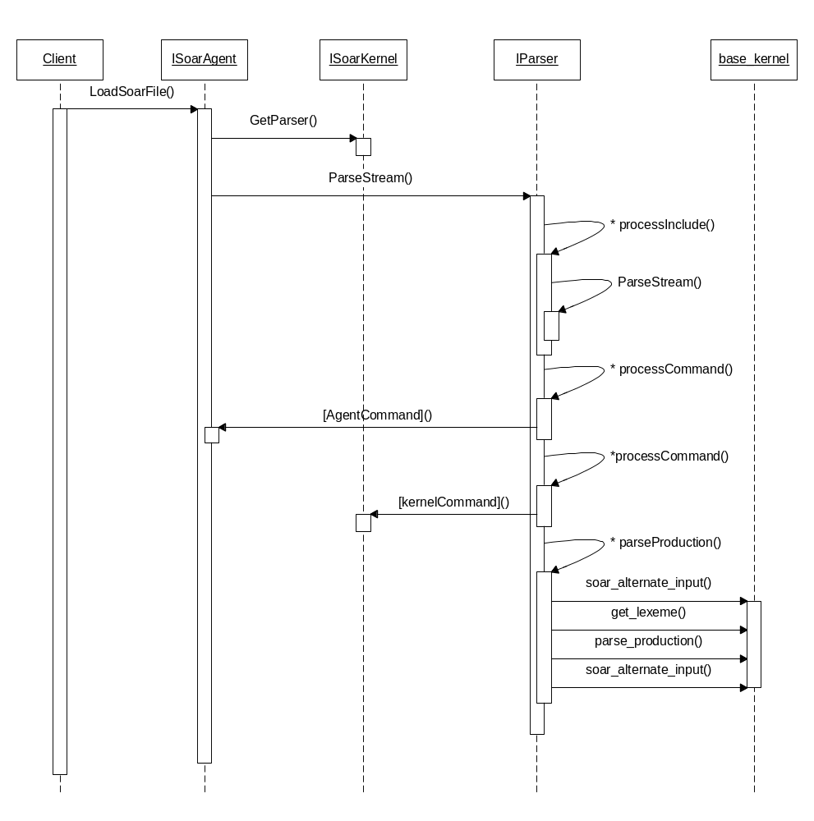

Logging:

gSKI will support two types of logging. The first type is internal logging used for debugging and error handling. This logger does not need an external interface. It can be turned on and off through the ISoarKernel interface. The internal logger supports the following:

- Logging the following different types of messages:
a. Error messages: Possibly non-recoverable condition that has no good default solution.
  - Warning message: Recoverable condition that has a good default solution. Nevertheless, the solution is probably not what was expected by the user.
  - Info message: Information regarding processing occurring in the gSKI and kernel. These are not errors or warnings (e.g. “Opened file for reading successfully.”)
  - Debug message: A message that should only appear in the debug version of gSKI. Can be for any reason.
- Configuration of the log files. The user can specify the file to which each type of message is sent.
- Configuration of log output activity. By default the system will not output logs. Logging can be turned on through the ISoarKernel interface.
- Log messages can be routed through the event interface using the LOG_ERROR, LOG_WARNING, LOG_INFO, and LOG_DEBUG events. This allows a client to handle the log as it sees fit.

The second type of logging provided by gSKI will provide detailed logs of agent activity for use in testing. This logger will piggyback on the gSKI event system as seen in the figure below:

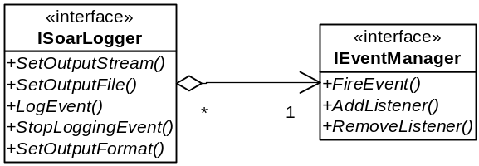

This general logger will allow the following:

- Selection of which events will be logged and which will not be logged. We may want to provide a configuration file for this.
- Selection of the file and/or stream to which the log is output.
- Selection of the output format of the data. This may not be necessary if one data format will serve everyone (e.g. XML).

